A Morphological and Syntactical Error Analysis in English as a Foreign Language Learners' Written Recount Texts: A Surface Strategy Taxonomy Approach
Submitted to fullfill the requirements for Bachelor Degree (S1) at English Education Department Faculty of Educational Teachers’ Training


By :
ULA AULIA RAHMAT
41032122221019

ENGLISH EDUCATION DEPARTMENT
FACULTY OF EDUCATION AND TEACHERS TRAINING
UNIVERSITAS ISLAM NUSANTARA
2026

STATEMENT OF ORIGINALITY

The undersigned:
Name: Ula Aulia Rahmat
Student ID: 41032122221019
Study Program: English Education
Faculty: Teacher Training and Education
University: Universitas Islam Nusantara
I hereby declare that this undergraduate thesis, entitled "A Morphological and Syntactical Error Analysis in English as a Foreign Language Learners' Written Recount Texts: A Surface Strategy Taxonomy Approach" is my original work, submitted to fulfill the academic requirements of my study program. To the best of my knowledge, this thesis does not contain material published or written by others, except where proper acknowledgment is provided through citations and references in accordance with academic writing standards.
I understand that plagiarism and other forms of academic misconduct constitute serious violations of academic ethics. Accordingly, I accept full responsibility for the originality of this thesis and acknowledge that any proven violation may result in academic sanctions in accordance with the regulations of Universitas Islam Nusantara. Should any claim arise regarding the authenticity of this work in the future, I am prepared to accept all resulting consequences.

Bandung, July 2026
Declared by

Ula Aulia Rahmat

PERSONAL PAGE
“Be in the sky but still have you feet on the ground.”
Mark Lee

ABSTRACT
This study aims to identify and classify the morphological and syntactical errors produced by English as a Foreign Language learners in their written recount texts, and to determine which types of error occur most frequently. It employs a qualitative content analysis with descriptive quantitative support, and the data consist of thirty-seven recount texts written by tenth-grade students of SMAN 9 Garut. Recount texts were selected because the genre obliges every writer to mark past time, to sequence events chronologically, and to refer back to real participants, so that difficulties of word formation and difficulties of sentence construction surface together within a single piece of writing. The novelty of the study lies in a two-stage analytical model. George Yule's account of morphology and syntax is first used to establish the linguistic level at which an error occurs, and Dulay, Burt and Krashen's Surface Strategy Taxonomy is then applied to classify the surface form of that error as omission, addition, misformation or misordering; the sequence is grounded in Corder's Error Analysis Theory and Selinker's Interlanguage Theory. Of the 214 errors identified, syntactical errors were slightly more frequent than morphological ones, and misformation emerged as the dominant surface category, driven mainly by inaccurate past-tense and verb forms. Pedagogically, the model allows educators to convert error data into remedial activities and targeted feedback. This is because it not only identifies the extent to which a form deviates from the target but also determines whether the learner's challenge is in the formation of words or the construction of sentences.
Keywords: EFL Learners; morphological errors; syntactical errors; Surface Strategy Taxonomy; recount text writing

PREFACE
This research is entitled “A Morphological and Syntactical Error Analysis in English as a Foreign Language Learners' Written Recount Texts: A Surface Strategy Taxonomy Approach”. The background of the research explained the challenges faced by EFL learners in mastering English grammar, the operational definition of morphological and syntactical errors in written language, the aim of the research, and the significance of the research.
In the literature review provides brief explanations about the theories of error analysis, the distinctions between morphological and syntactical errors, and the framework of Surface Strategy Taxonomy, in which errors can be categorized into omission, addition, misformation, and misordering.
This research has chosen a qualitative descriptive method, utilizing written student artifacts in the form of recount texts as the instrument to get the data, and used the error analysis procedure to identify, classify, and explain the errors. The participants are the high school learners who are studying English as a foreign language.
The findings and discussion provided the results of the error identification, namely the types of morphological and syntactical errors frequently made by the students and the factors causing these errors. This research is far from perfection. Therefore, feedback such as suggestions and constructive criticism from the reader is needed for its perfection.

Bandung, July 2026

The Researcher

LEGALIZATION SHEET

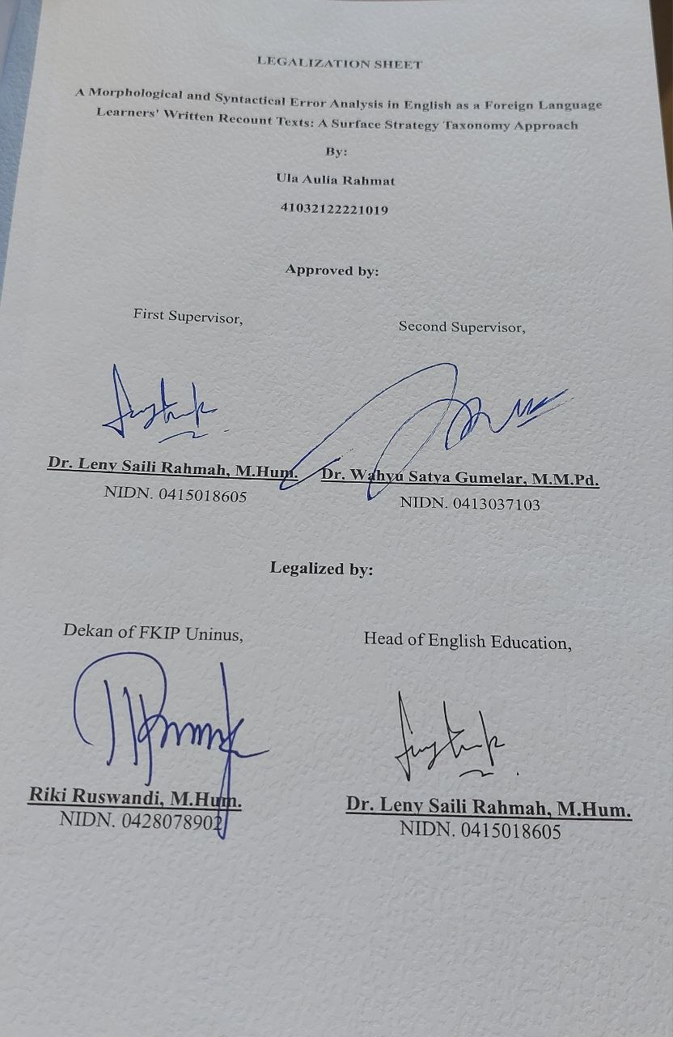

ACKNOWLEDGEMENT
Alhamdulillahi Rabbil ‘alamin
All praise and sincere gratitude are devoted to Allah SWT, the Most Gracious and the Most Merciful. Through His blessings, mercy, strength, and guidance, I have completed this undergraduate thesis. Every achievement in my academic journey has been possible only by His permission and countless favors. I am profoundly grateful for His love, protection, and wisdom throughout every challenge and success.
May peace and blessings be upon Prophet Muhammad SAW, whose noble character and teachings inspire patience, perseverance, compassion, and integrity in all aspects of life.
The completion of this thesis was made possible by the encouragement, guidance, and support of many remarkable individuals. I would like to express my heartfelt appreciation to:
With love, I dedicate this work to:
- Prof. Dr. Endang Komara, M.Si., Rector of Universitas Islam Nusantara, for providing students with the opportunity and academic environment to pursue and complete their undergraduate studies.
- Dr. Leny Saily Rahmah, M.Hum., Head of the English Education Study Program and my academic supervisor, for his invaluable guidance, constructive feedback, patience, and continuous encouragement throughout the completion of this thesis. His dedication and support have greatly contributed to both my academic and personal development.
- Dr. Wahyu Satya Gumelar, M.M.Pd., my second supervisor, for his inspiring lectures, motivation, and valuable advice. I am sincerely grateful for the meaningful lessons and confidence he instilled throughout my academic journey.
- Mr. Riki Ruswandi, M.Hum., Dean of the Faculty of Teacher Training and Education, for his support, guidance, and encouragement throughout my academic journey. I sincerely appreciate the valuable support and contribution to the completion of this thesis.
- All lecturers of the English Education Study Program, for generously sharing their knowledge, experience, and encouragement throughout my years of study. Their commitment has played an important role in shaping my academic growth and professional aspirations.
- The Principal, the English teacher, and all students of SMAN 9 Garut class X-12 for their gracious reception and for granting permission to conduct this research. I particularly acknowledge the student participants for their cooperation, enthusiasm, and readiness to dedicate time and effort during data collection. Without their invaluable participation, this study would not have been feasible.
- My beloved family, thank you for your endless love, prayers, encouragement, understanding, and unwavering support throughout every stage of my academic journey. Your belief in me has been my greatest source of strength, especially during the most challenging moments. I am truly grateful to have a family that always stands by my side and supports every decision and dream I pursue.
- My beloved classmates of the English Education Study Program, thank you for being my companions throughout these incredible four years. From our first days as university students to the completion of our undergraduate journey, we have grown, learned, struggled, laughed, and succeeded together. Every shared experience has become a valuable memory that I will always cherish. I am truly thankful to have spent this chapter of my life with all of you, and I hope our friendship will continue long after graduation.
- My dearest friend, Laela, who has been by my side since childhood and has witnessed every chapter of my journey. Thank you for growing up with me, sharing countless memories, and always believing in my abilities even when I doubted myself. Your constant presence, sincere friendship, and unwavering support have been a source of comfort and strength throughout the years. I am truly grateful to have someone like you walking beside me through every stage of life.
- My beloved friends, Lilic, Isna, Ama, Ica, and Eca, thank you for being my closest companions throughout my university years. We have shared countless moments together, from attending classes, working on assignments, spending time together, to supporting each other through the long and challenging process of completing our theses. Your encouragement, laughter, understanding, and unwavering presence have made this journey far more meaningful and enjoyable. I truly believe that without your friendship and support, I would not have been able to make it this far. Thank you for becoming my safe place during both the happiest and the most difficult moments. I will always cherish the memories we created together and hope our friendship continues long after graduation.
- Last but not least, to all the members of NCT, including NCT 127, NCT DREAM, WayV, and NCT WISH, thank you for unknowingly becoming a constant source of comfort and encouragement throughout my academic journey. Your music, performances, and various content have accompanied me through countless days and nights, bringing joy during difficult moments and motivation during times of exhaustion. Whenever I felt overwhelmed by academic responsibilities, your work became a small escape that helped me regain my energy and continue moving forward. Thank you for filling my days with laughter, inspiration, and positivity, making this journey a little lighter and much more meaningful.
- A very special appreciation goes to Mark Lee. Beyond being an artist, your perseverance, discipline, and passion for continuous learning have been one of the reasons I chose to pursue a degree in English Education. The insights you have shared through interviews, lyrics, and your personal journey have taught me the importance of believing in myself, embracing challenges, and never giving up on my dreams. During the process of completing this thesis, your words often reminded me to keep going even when I felt exhausted or uncertain. Although this message may never reach you, your influence has become a meaningful part of my academic journey, and for that, I am sincerely grateful.

TABLE OF CONTENTS

TITLE PAGE i
STATEMENT OF ORIGINALITY ii
PERSONAL PAGE iii
ABSTRACT iv
PREFACE v
LEGALIZATION SHEET vi
ACKNOWLEDGEMENT vii
TABLE OF CONTENTS xi
LIST OF TABLES xiv
LIST OF FIGURES xv
CHAPTER I INTRODUCTION 1
A. Background of The Study 1
B. Statement of The Problems 4
C. Objective of The Study 4
D. Scope and Limitations 5
E. Significance of The Study 5
CHAPTER II LITERATURE REVIEW 7
A. English as a Foreign Language (EFL) Learners 7
1. Definition of EFL 7
2. Characteristics of EFL Learners 7
3. Challenges in EFL Writing 8
4. EFL Writing in the Indonesian Context 9
B. Morphology 10
1. Definition of Morphology 10
2. Morpheme 11
3. Types of Morphemes 12
4. Inflectional Morphemes 13
5. Morphological Errors in EFL Writing 15
C. Syntax 17
1. Definition of Syntax 17
2. Sentence Structure 18
3. Phrase and Clause 18
4. English Word Order 19
5. Auxiliary Verbs 20
6. Subject–Verb Agreement 20
7. Syntactical Errors 21
8. Syntactical Errors in Recount Text Writing 22
D. Surface Strategy Taxonomy 23
1. Definition of Surface Strategy Taxonomy 23
2. Omission 24
3. Addition 26
4. Misformation 27
5. Misordering 28
6. Surface Strategy Taxonomy in Morphological and Syntactical Error Analysis 29
E. Recount Text 30
F. Previous Studies 32
CHAPTER III RESEARCH METHODOLOGY 35
A. Research Design 35
B. Research Setting (Location and Time) 35
C. Population and Sample 36
D. Research Instruments 36
E. Research Procedures 37
F. Data Analysis Techniques 39
CHAPTER IV FINDINGS AND DISCUSSION 41
A. Chapter Introduction 41
B. General Description of the Research 41
C. Research Findings 43
1. Two-stage identification of morphological and syntactical errors 43
2. Classification of errors based on Surface Strategy Taxonomy 48
D. Discussion 52
1. Morphology and syntax as the first level of analysis 52
2. Surface Strategy Taxonomy as the second level of analysis 55
3. Interpretation of the result displays 58
4. Pedagogical implications for recount text writing 60
CHAPTER V CONCLUSION AND SUGGESTIONS 63
A. Conclusion 63
B. Suggestions 64
LIST OF REFERENCES 66
LIST OF APPENDICES 72

LIST OF TABLES
Table 2. 1 Examples of Morpheme Analysis 12
Table 2. 2 Eight Inflectional Morphemes in English (Yule, 2020) 14
Table 2. 3 Examples of Morphological Errors in EFL Recount Writing 16
Table 4. 1 Coding matrix for morphological and syntactical errors 44
Table 4. 2 Distribution of linguistic areas based on survey coding 46
Table 4. 3 Distribution of Surface Strategy Taxonomy categories based on survey coding 48
Table 4. 4 Relationship between linguistic area and surface category based on survey coding 50

LIST OF FIGURES
Figure 4.1 Distribution of morphological and syntactical errors based on survey coding 47
Figure 4.2 Percentage of Surface Strategy Taxonomy categories based on survey coding 50
Figure 4.3 Distribution of detailed error subtypes based on survey coding 51

