EFL SENIOR HIGH SCHOOL STUDENTS' PERSPECTIVES ON USING SOCIAL MEDIA PLATFORMS FOR ENGLISH VOCABULARY ACQUISITION

A RESEARCH PAPER
Submitted to the English Education Department of Universitas Islam Nusantara Bandung As One of The Requirements for Getting a Bachelor's Degree


Arranged By
DILLA HILDA RAHAYU
41032122221042

ENGLISH EDUCATION STUDY PROGRAM
FACULTY OF TEACHER TRAINING AND EDUCATION
UNIVERSITAS ISLAM NUSANTARA
2026

TABLE OF CONTENTS
TABLE OF CONTENTS .....................................................................................ii
LIST OF TABLES AND FIGURES iv
LEGALIZATION SHEET ...................................................................................v
MOTTO vi
STATEMENT OF ORIGINALITY vii
ACKNOWLEDGEMENT viii
ABSTRACT x
CHAPTER I 1
INTRODUCTION 1
A. Background of the Study 1
B. Limitation of the Problem 3
C. Research Problem 3
D. Research Objectives 3
E. Benefit of the Research 4
1). Theoretical Benefits 4
2). Practical Benefits 5
CHAPTER II 6
LITERATURE REVIEW 6
A. Theoretical Framework 6
1. Social Media as Learning Tools 6
2. English as a Foreign Language 9
3. Learning English Vocabulary 10
B. Previous Research 12
CHAPTER III 16
METHODOLOGY 16
A. Research Design 16
B. Research Location and Time 17
C. Population and Sample 17
D. Research Instrument 18
E. Research Procedures 19
F. Data Analysis Technique 20
CHAPTER IV 21
RESEARCH FINDINGS AND DISCUSSION 21
A. Research Findings 21
1. Questionnaire 21
2. Interviews 24
B. Discussion 37
1. Students’ Perspectives and Challenges on Using Social Media for Vocabulary Acquisition 37
2. Features of Social Media that Support Vocabulary Acquisition 59
CHAPTER V 78
CONCLUSION AND SUGGESTION 78
A. Conclusion 78
B. Suggestion 80
REFERENCES 81
APPENDIX 84

LIST OF TABLES AND FIGURES

TABLES
Table 4.1.1. Result Data of Questionnaire ............................................................22
Table 4.2.1. (Theme 1 of Question 1) ...................................................................25
Table 4.2.2. (Theme 2 of Question 2) ...................................................................26
Table 4.2.3. (Theme 3 of Question 3) ...................................................................27
Table 4.2.4. (Theme 4 of Question 4) ...................................................................29
Table 4.2.5. (Theme 5 of Question 5) ...................................................................30
Table 4.2.6. (Theme 6 of Question 6) ...................................................................31
Table 4.2.7. (Theme 7 of Question 7) ...................................................................33
Table 4.2.8. (Theme 8 of Question 8) ...................................................................34

FIGURES
Figure 4.2.1. Example of vocabulary-learning content on YouTube featuring authentic daily conversations supported by English subtitles ...............................36
Figure 4.2.2. Example of TikTok vocabulary-learning content featuring visual illustrations, pronunciation, and captions ..............................................................36

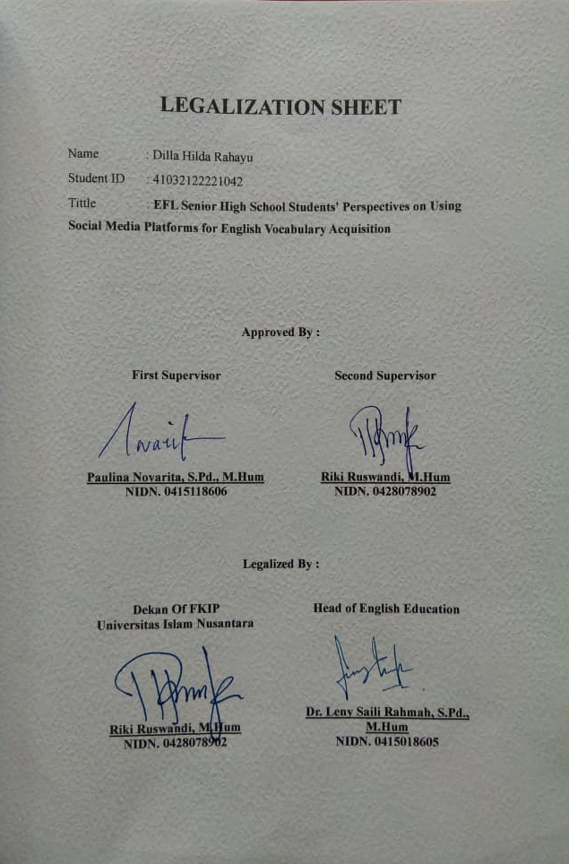

MOTTO

It always seems impossible until it’s done
(Nelson Mandela )

And that man will have nothing except what he strives for
(QS. An-Najm: 39)

Behind every step I take, there is a mother whose prayers never cease
(Dilla Hilda Rahayu)

STATEMENT OF ORIGINALITY

I hereby declare that this thesis entitled “EFL Senior High School Students' Perspectives on Using Social Media Platforms for English Vocabulary Acquisition” is entirely my own original work and has been written based on the research and academic work that I have conducted. This thesis has been prepared as one of the requirements for completing my undergraduate degree at Universitas Islam Nusantara.
I certify that all ideas, arguments, data, findings, interpretations, and statements presented in this thesis are the result of my own work, except for those parts that have been explicitly acknowledged and properly cited. All sources of information, including books, journal articles, websites, previous studies, and other references, have been appropriately cited and listed in the references according to the applicable academic writing guidelines.
I further declare that this thesis has not been copied, reproduced, or substantially taken from another person's work without proper acknowledgment. I also confirm that this thesis has not previously been submitted, either in whole or in part, to any other educational institution or academic program for the purpose of obtaining a degree or academic qualification.
This statement is made truthfully and conscientiously, with the understanding that it will be used as part of the academic requirements for the completion of my undergraduate study.

Bandung, August 2026
The Researcher,

Dilla Hilda Rahayu
41032122221042

ACKNOWLEDGEMENT

All praise and gratitude are due to Allah SWT for His endless blessings, guidance, strength, and mercy, which have enabled me to complete this thesis. Throughout this journey, I have received immense support, kindness, and encouragement from many people. Therefore, I would like to sincerely express my gratitude to:
1. Paulina Novarita, S.Pd., M.Hum., as my first thesis supervisor, for her valuable guidance, patience, constructive feedback, and continuous support throughout the process of completing this thesis. I am truly grateful for every correction, suggestion, and piece of advice that helped me improve this work and grow as a student and researcher.
2. Riki Ruswandi, M.Hum., as my second thesis supervisor, for his valuable guidance, thoughtful feedback, patience, and support during the completion of this thesis. I sincerely appreciate the time and effort he devoted to helping me complete this research.
3. My beloved mother, the person I would like to thank most deeply. Thank you for every prayer, sacrifice, encouragement, and unconditional love you have given me throughout my life. Thank you for always believing in me, even during the moments when I struggled to believe in myself. You have been my greatest source of strength and the person who has always reminded me to keep going. I know that no words could ever be enough to repay everything you have done for me. This achievement is not mine alone; it is also yours, because behind every step I have taken, there has always been your prayer, love, and support. I hope that this thesis, no matter how small it may seem, can be one of the things that makes you proud. Thank you for being my home, my strength, and one of the greatest blessings in my life. This is for you, Mom.
4. My beloved younger sibling, whom I am always proud of, thank you for being an important part of my life. Your presence has brought so much happiness and warmth into my days. Although I may not always say it, I am truly grateful to have you as my sibling. I hope that you will always believe in yourself, pursue your dreams with courage, and become the person you aspire to be. I will always be proud of you and will always wish the best for you.
5. My friends in the English Education Department, thank you for being part of my university journey. Thank you for the laughter, conversations, encouragement, help, shared struggles, and countless memories we created together. Thank you for making these years more meaningful and for reminding me that I was never completely alone throughout this journey. We may eventually walk on different paths, but I will always cherish the memories we made and be grateful that I had the chance to meet and grow alongside all of you.
Lastly, I would like to thank everyone who has supported me, whether directly or indirectly, throughout the process of completing this thesis. Every prayer, kind word, helping hand, and simple act of support has meant more to me than I can express. This thesis is not only the result of my own efforts, but also a reflection of the love, guidance, and support I have received from the people around me.
Thank you for being part of my journey and for helping me become the person I am today.

Bandung, August 2026
The Researcher,

Dilla Hilda Rahayu
41032122221042

ABSTRACT

This study was motivated by the increasing use of social media platforms as informal learning resources for English vocabulary acquisition among EFL students. Although social media is widely used for educational purposes, students' perspectives, learning experiences, and the features supporting vocabulary acquisition require further exploration. Therefore, this study investigated EFL senior high school students' perspectives, challenges, and perceived beneficial features of using social media platforms for English vocabulary acquisition outside the classroom. This study employed a qualitative case study design involving approximately 300 eleventh-grade students at SMAN 1 Banjaran, West Java, Indonesia. Data were collected through a screening questionnaire completed by 80 students, a main questionnaire administered to 25 purposively selected participants, and semi-structured interviews with five participants selected through maximum variation sampling. The findings revealed that students generally perceived TikTok and YouTube as engaging, accessible, and contextual platforms for vocabulary acquisition. Features such as subtitles, translation tools, audiovisual content, and example sentences facilitated vocabulary learning, whereas distractions, fast-paced content, limited feedback, and inconsistent content quality remained major challenges

